

**perilous**

**dismay**

**gravelly**



**apparatus**

**prestigious**

**essential**

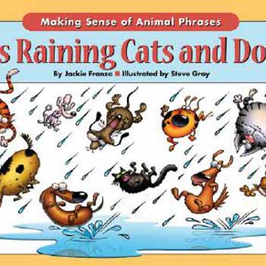

**deteriorate**

**peculiar**

**excursion**



**monotonously**

**tersely**

**barren**

**bedlam**

**uncanny**

**supremacy**

**momentum**

**Conscientioulsly**

**ponderously**



**docility**

**cunning**

**vicious**



**intrinsic**

**murky**

**futile**